**1.** consider the following lines of code, what is the name of the column that contains the target values:

1 from sklearn.linear_model import LinearRegression

2 lm=LinearRegression()

3 X = df[['highway-mpg']]

4 Y = df['price']

5 lm.fit(X, Y)

6 Yhat=lm.predict(X)

* 'price'
* 'highway-mpg'

**2.** consider the following equation:

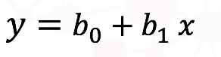

what is the parameter b_0 (b subscript 0)

* the predictor or independent variable
* the target or dependent variable
* the intercept
* the slope